Decision Tree using Gini Index

| **Weekend** | **Weather** | **Parents** | **Money** | **Decision** |
| --- | --- | --- | --- | --- |
| W1 | Sunny | Yes | Rich | Cinema |
| W2 | Sunny | No | Rich | Tennis |
| W3 | Windy | Yes | Rich | Cinema |
| W4 | Rainy | Yes | Poor | Cinema |
| W5 | Rainy | No | Rich | Stay In |
| W6 | Rainy | Yes | Poor | Cinema |
| W7 | Windy | No | Poor | Cinema |
| W8 | Windy | No | Rich | Shopping |
| W9 | Windy | Yes | Rich | Cinema |
| W10 | Sunny | No | Rich | Tennis |

**Output**

| **Decision** |
| --- |
| Cinema |
| Tennis |
| Cinema |
| Cinema |
| Stay In |
| Cinema |
| Cinema |
| Shopping |
| Cinema |
| Tennis |

Cinema =6/10

Tennis= 2/10

Stay In=1/10

Shopping=1/10

* $Gini\left(s\right)= 1-[{\left(\frac{6}{10}\right)}^{2}$ + ${\left(\frac{ 2 }{10}\right)}^{2}$ + ${\left(\frac{1}{10}\right)}^{2}$ + ${\left(\frac{1}{10}\right)}^{2}$] = 0.58

Weather

| **Weather** | **Decision** |
| --- | --- |
| **Sunny** | Cinema |
| **Sunny** | Tennis |
| Windy | Cinema |
| Rainy | Cinema |
| Rainy | Stay In |
| Rainy | Cinema |
| Windy | Cinema |
| Windy | Shopping |
| Windy | Cinema |
| **Sunny** | Tennis |

Sunny = 1/3

2/3

* Computation of Gin Index for Weather Attribute
* It has three possible values of Sunny (3 examples) , Rainy (3 examples) and Windy (4 examples).
* For Weather = Sunny , there are 2 examples, all with “Cinema=1” and 1 with “Tennis=2”.
$Gini\left(sunny\right)= 1-\left[{\left(\frac{2}{3}\right)}^{2}+ {\left(\frac{1}{3}\right)}^{2}\right]= 0.444$

* For Weather= Rainy, there are 2 examples with “Cinema”, 1 examples with “Stay In”.
* $Gini\left(Rainy\right)= 1-[{\left(\frac{2}{3}\right)}^{2}$ + ${\left(\frac{ 1 }{3}\right)}^{2}$] = 0.444
* For Weather= Windy, there are 3 examples with “Cinema” and 1 example with “Shopping”.
* $Gini\left(Windy\right)= 1-[{\left(\frac{3}{4}\right)}^{2}$ + ${\left(\frac{ 1 }{4}\right)}^{2}$] = 0.375

| **Weather** | **Decision** |
| --- | --- |
| **Sunny** | Cinema |
| **Sunny** | Tennis |
| Windy | Cinema |
| Rainy | Cinema |
| Rainy | Stay In |
| Rainy | Cinema |
| Windy | Cinema |
| Windy | Shopping |
| Windy | Cinema |
| **Sunny** | Tennis |

sunny = 2/3 1/ 3

windy = 3 / 4 , 1/4 rainy = 2 /3 , 1/3

$Gini\left(sunny\right)= 1-\left[{\left(\frac{2}{3}\right)}^{2}+ {\left(\frac{1}{3}\right)}^{2}\right]= 0.444$

* $Gini\left(Windy\right)= 1-[{\left(\frac{3}{4}\right)}^{2}$ + ${\left(\frac{ 1 }{4}\right)}^{2}$] = 0.375
* $Gini\left(Rainy\right)= 1-[{\left(\frac{2}{3}\right)}^{2}$ + ${\left(\frac{ 1 }{3}\right)}^{2}$] = 0.444

**Weighted Average (Weather)**

= 0.444 $\left(\frac{3}{10}\right)$* + 0.444 $\left(\frac{3}{10}\right)$* + 0.375 $\left(\frac{4}{10}\right)$

*

= 0.416

Parents

| **Parents** | **Decision** |
| --- | --- |
| Yes | Cinema |
| No | Tennis |
| Yes | Cinema |
| Yes | Cinema |
| No | Stay In |
| Yes | Cinema |
| No | Cinema |
| No | Shopping |
| Yes | Cinema |
| No | Tennis |

Yes = 5/5

No = 1/5 (Cine) , 2 / 5 (Tenn), 1/5 (Stay), 1 / 5 (Shopp)

Computation of Gin Index for **Parent** Attribute

It has two possible values of Yes (5 examples) and No (5 examples).

For Parents = Yes , there are 5 examples, all with “Cinema”.

$Gini\left(s\right)= 1-\left[{\left(\frac{5}{5}\right)}^{2}\right]= 0$

For Parents = No, there are 2 examples with “Tennis”, 1 examples with “Stay In”, “Shopping” and “Cinema” each

+ + + ] = 0.72

**Weighted Average (parent)**

= 0 + 0.72 $\left(\frac{5}{10}\right)$

*

For Parents – Gini Index : 0.36

| **Money** | **Decision** |
| --- | --- |
| Rich | Cinema |
| Rich | Tennis |
| Rich | Cinema |
| Poor | Cinema |
| Rich | Stay In |
| Poor | Cinema |
| Poor | Cinema |
| Rich | Shopping |
| Rich | Cinema |
| Rich | Tennis |

Rich = 3/ 7 (Cinema) , 2/7(Tenn) , 1/7 stay in, 1/7 shopping

poor= 3/3(cinema)

Computation of Gin Index for Money Attribute

It has two possible values of Rich (7 examples) and Poor (3 examples).

**For Money = Poor ,** there are 3 examples with “Cinema”.

$Gini \left(s\right)poor= 1-\left[{\left(\frac{3}{3}\right)}^{2}\right]= 0$

**For Money = Rich**, there are 2 examples with “Tennis”, 3 examples with “Cinema” and 1 example with “Stay In”, “Shopping” each

+ + + ] = 0.694

**Weighted Average (money)**

= 0 + 0.694 $\left(\frac{7}{10}\right)$

*

= 0.486

For Money – Gini Index: 0.486

**Iteration One**

For Weather – Gini Index : 0.416

**For Parents – Gini Index : 0.36**

For Money – Gini Index: 0.486

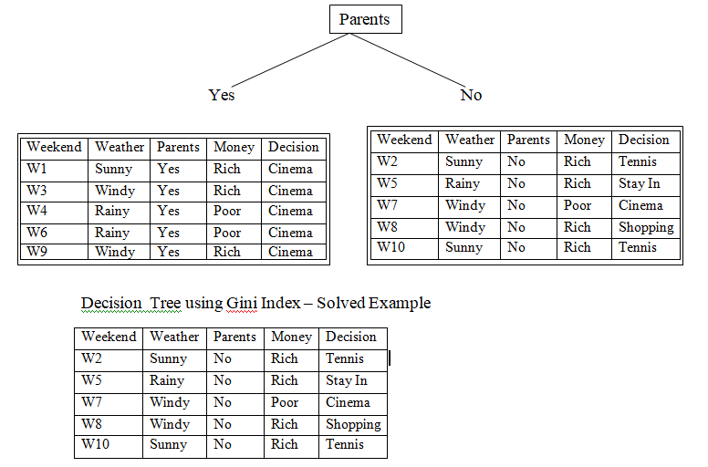

Iterating 2

| **Weekend** | **Weather** | **Parents** | **Money** | **Decision** |
| --- | --- | --- | --- | --- |
| W2 | Sunny | No | Rich | Tennis |
| W5 | Rainy | No | Rich | Stay In |
| W7 | Windy | No | Poor | Cinema |
| W8 | Windy | No | Rich | Shopping |
| W10 | Sunny | No | Rich | Tennis |

| **Weekend** | **Weather** | **Money** | **Decision** |
| --- | --- | --- | --- |
| W2 | Sunny | Rich | Tennis |
| W5 | Rainy | Rich | Stay In |
| W7 | Windy | Poor | Cinema |
| W8 | Windy | Rich | Shopping |
| W10 | Sunny | Rich | Tennis |

**Parents = No | Weather Attribute**

| **Weather** | **Decision** |
| --- | --- |
| Sunny | Tennis |
| Rainy | Stay In |
| Windy | Cinema |
| Windy | Shopping |
| Sunny | Tennis |

Computation of Gini Index for **Parents = No | Weather Attribute**

Windy (2 example)

For Parents =**No | Weather = Windy**, there is 1 example with “Cinema” and 1 example with “ Shopping”.

$windy Gini\left(s\right)= 1-\left[{\left(\frac{1}{2}\right)}^{2}+ {\left(\frac{1}{2}\right)}^{2}\right]= 0.5$

$Sunny Gini\left(s\right)= 1-\left[{\left(\frac{2}{2}\right)}^{2}\right]= 0$

$Rainy Gini\left(s\right)= 1-\left[{\left(\frac{1}{1}\right)}^{2}\right]= 0$

**Weighted Average(Parents = No | Weather)**  
 =0 $\left(\frac{2}{5}\right)$*+ 0 $\left(\frac{1}{5}\right)$* + 0.5 $\left(\frac{2}{5}\right)$* = 0.2

Computation of Gini Index for **Parents = No | Money Attribute**

| **Money** | **Decision** |
| --- | --- |
| Rich | Tennis |
| Rich | Stay In |
| Poor | Cinema |
| Rich | Shopping |
| Rich | Tennis |

Computation of Gini Index for Parents = No | Money Attribute

Poor (1 example)

For Parents =No | Money = Poor, there is 1 example with “Cinema”.

$Gini\left(s\right)= 1-\left[{\left(\frac{1}{1}\right)}^{2}\right]= 0$

Rich

$Gini\left(s\right)= 1-\left[{\left(\frac{2}{4}\right)}^{2}+{\left(\frac{1}{4}\right)}^{2}+{\left(\frac{1}{4}\right)}^{2}\right]= 0.625$

Weighted Average(Parents = No | Money)  
 =0.625 $\left(\frac{4}{5}\right)$*+ 0 $\left(\frac{1}{5}\right)$* = 0.5

Weighted Average(Parents = No | **Weather**)  
 =0 $\left(\frac{2}{5}\right)$*+ 0 $\left(\frac{1}{5}\right)$* + 0.5 $\left(\frac{2}{5}\right)$* = 0.2

Weighted Average(Parents = No | **Money)** =0.625 $\left(\frac{4}{5}\right)$*+ 0 $\left(\frac{1}{5}\right)$* = 0.5

